APARTMENT VISITORS MANAGEMENT SYSTEM

Table of contents

1. Project Overview 2

2. Purpose of the system 2

3. Key Users and their Roles 2

5. System Modules and Features 3

6. Core Functionalities 4

5. Database Design 4

# Project Overview

The Apartment Visitors Management System is a digital solution designed to secure the process of managing visitors to residential apartment buildings. The system is aimed at replacing traditional paper logs with a digital platform that allows real-time monitoring, and tracking of all previous visits.

# Purpose of the system

Enhance security by maintaining digital records of all visitors.

Streamline visitor check-in and check-out processes.

Allow property management to monitor visitor traffic.

Generate reports for security audits and building management.

Reduce unauthorized access to the property.

# Key Users and their Roles

1. Residents

To encourage expected visitors to use the system and generate a visiting permit.

To receive information about an expected visitor

Receive notifications when visitors arrive

Provide pre-approved visitor lists

1. Visitors

Comply with the check-in and check-out procedures

State visit purpose, resident name, and resident apartment number

Provide identification information

Receive temporary access credentials

1. Property Managers

Oversee overall system usage, especially visitors.

View and analyze visitor reports

Manage user accounts for security personnel

1. Security Personnel

Process visitor check-ins and check-outs

Verify visitor identities

Handle registration visitors

Monitor visitor logs in real-time

Handle security incidents

Contact residents for visitor approval

# System Modules and Features

1. Visitor Registration Module

Walk-in visitor processing

Capture visitor information (name, contact info, National ID details, and purpose of visit)

Digital visitor pass that can be shared via email.

1. Security Management Module

Real-time monitoring of all visitors on the premises.

Digital logbook for security personnel

Visitor management (previous visitors, current visitors, common visitors)

1. Manager Module

Visitor traffic analysis (daily, weekly, monthly reports)

Analysis of peak visiting hours identification.

Export capabilities (PDF)

Building/unit management

Resident-specific visitor statistics

User account management (security personnel)

1. Check-in/Check-out Module

Check-in process for expected visitors.

Process for handling unregistered visitors.

Check-out process to track departure times.

# Core Functionalities

1. **Visitor Registration Module**

The core functionality includes capturing essential visitor information, creating digital visiting permits with unique identifiers, and establishing the purpose and duration of visits. The module handles both pre-planned and spontaneous visits, maintaining a centralized database of all visitor information that can be quickly accessed by authorized personnel.

1. **Security Management Module**

This module equips security personnel with tools to maintain property security through visitor monitoring. It provides a comprehensive dashboard displaying all active visitors on the premises and a dashboard for check-ins and check-outs. The system enables the Askari to identify unauthorized access attempts with forged permits, manage visitor lists, and check-in/check-out visitors.

1. **Manager Module**

This module provides property managers with comprehensive reporting capabilities:

* Executive dashboard presenting critical visitor statistics
* An analytics engine that processes visitor data to identify patterns.
* Peak hour analysis with graphical representation.
* User account management for security personnel with tasks sent to their dashboard.

1. **Check-in/Check-out Module**

This module manages the physical access to the premises, and the Askari manages it. The functionality includes:

* Streamlined check-in process with verification against preregistered information.
* Special handling steps for unregistered visitors with immediate registration capability.
* Visitor monitoring to prevent overstaying beyond what was initially planned, for example, delivery guys.

# Database Design

|  |  |
| --- | --- |
| Entity | Attribute |
| Visitor | visitorID (Primary key)  firstName  lastName  nationalID  phone  visitorType (Delivery, Service Provider)  email |
| Resident | residentID (Primary key)  firstName  lastName  apartmentNumber  phone  preferredContact |
| PropertyManager | managerID (Primary key)  firstName  lastName  phone  email |
| SecurityPersonnel (Askari) | securityID (Primary Key)  firstName  lastName  phone  email |
| VisitorPermit | visitID (PK)  visitorID (FK)  residentID (FK)  visitType  visitDate  permitStatus  checkInTime  checkOutTime |
| VisitorLog | LogID (Primary Key)  VisitorID (Foreign Key)  EntryDateTime  ExitDateTime  Duration  VisitPurpose  ResidentVisited (Foreign Key)  ProcessedBy (SecurityID Foreign Key) |
| Apartment | apartmentID (Primary Key)  apartmentNumber  Floor  residentID (FK) |

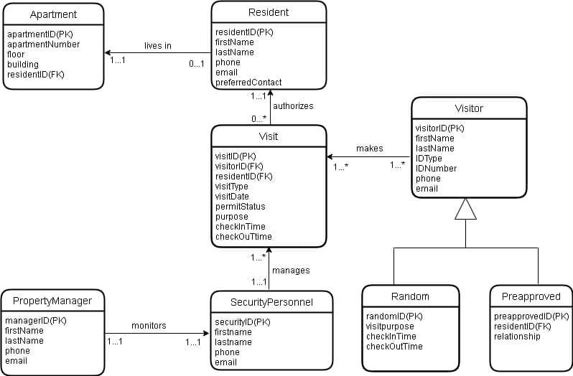

*Figure 1. An Entity-Relationship Diagram of the system*

**Data Dictionary**

Visitor

|  |  |  |  |  |
| --- | --- | --- | --- | --- |
| attribute | Data type | Size | key | description |
| visitorID (PK) | varchar | 15 | Primary Key | The unique identifier for the visitor |
| firstName | varchar | 20 |  | The first name of the visitor |
| lastName | varchar | 15 |  | The last name of the visitor |
| phone | varchar | 15 |  | The phone number of the visitor |
| email | varchar | 20 |  | The email of the visitor |

*Visitor Table: records of all individuals visiting the property.*

Visit

|  |  |  |  |  |
| --- | --- | --- | --- | --- |
| attribute | Data type | Size | key | description |
| visitID (PK) | varchar | 15 | Primary Key | The unique identifier of the permit |
| visitorID (FK) | varchar | 15 | Foreign Key | The unique identifier of the visitor |
| residentID (FK) | varchar | 10 | Foreign Key | The unique identifier of the resident |
| visitType | text | 15 |  | The category of the visit |
| visitDate | date | 10 |  | The date of the visit |
| permitStatus | text | 10 |  | It is either valid or expired |
| purpose | text | 20 |  | The purpose of the visit |
| checkInTime | time | 5 |  | The time the visitor arrives |
| checkOutTime | time | 5 |  | The time the visitor leaves |

*Visits Table: Log of all visits*

Resident

|  |  |  |  |  |
| --- | --- | --- | --- | --- |
| attribute | Data type | Size | key | description |
| residentID (PK) | varchar | 15 | Primary Key | Unique identifier of the resident |
| firstName | varchar | 10 |  | The first name of the resident |
| lastName | varchar | 15 |  | The last name of the resident |
| phone | varchar | 15 |  | The phone number of the resident |
| email | varchar | 20 |  | The resident’s email |
| preferredContact | varchar | 15 |  | The resident’s preferred contact. |

*Residents Table: Current occupants of the apartment unit*

Apartment

|  |  |  |  |  |
| --- | --- | --- | --- | --- |
| attribute | Data type | Size | key | description |
| ApartmentID (PK) | varchar | 10 | Primary Key | Unique identifier of the apartment |
| ApartmentNumber | varchar | 10 |  | The resident’s apartment Number |
| floor | Integer | 5 |  | The resident’s floor |
| residentID (FK) | varchar | 15 | Foreign Key | The resident’s unique identifier |

*Apartment Table: Property units and their specifications*

SecurityPersonnel

|  |  |  |  |  |
| --- | --- | --- | --- | --- |
| attribute | Data type | Size | key | description |
| securityID | varchar | 15 | Primary Key | Unique identifier for Askari |
| firstName | varchar | 15 |  | First name of Askari |
| lastName | varchar | 20 |  | Last name of Askari |
| phone | varchar | 15 |  | Phone Number of Askari |
| email | varchar | 20 |  | Email of Askari |

*Security Personnel Table: Staff responsible for property security*

PropertyManager

|  |  |  |  |  |
| --- | --- | --- | --- | --- |
| attribute | Data type | Size | key | description |
| managerID | varchar | 15 | Primary Key | Unique identifier of the Manager |
| firstName | varchar | 15 |  | First name of the Manager |
| lastName | varchar | 20 |  | Last name of the Manager |
| email | varchar | 20 |  | email of the Manager |

*Property Manager Table: Manager responsible for apartment building*